

AMERICAN INTERNATIONAL UNIVERSITY–BANGLADESH (AIUB)

Faculty of Science and Technology

Dept. of Computer Science

COURSE: COMPUTER GRAPHICS

Fall 2025-2026

Section: [N] (GROUP-2)

Project Name [Racer X-City Drift]

Supervised By:

TONNY SHEKHA KAR

Submitted By
Sadia Mahan Auti

Name |  | ID
1. | SADIA MAHAN AUTI | 23-52092-2
2. | MOHTASIN SHAHRIAR TANBIN | 23-52545-2
3. | SAIFUL ISLAM SHIMUL | 23-51336-1
Table of Contents
- Introduction ................................................................................................................XX
- Project Graph/Design .................................................................................................XX
- Game Levels ............................................................................................................... XX
- List of Objects Assigning an Object ID .................................................................... XX
- List of Functions to Represent Objects .....................................................................XX
- List of Animation Functions with ID .........................................................................XX
- Contribution .................................................................................................................XX
- Output ...........................................................................................................................XX
- Controls .........................................................................................................................XX
- Description of Project ...................................................................................................XX
- Functionalities ...............................................................................................................XX
- Important OpenGL Functions ....................................................................................XX
- Conclusion .....................................................................................................................XX

1. Introduction
The "Racer X-City Drift" is a 2D racing simulation game developed using OpenGL and C++. The game offers an immersive experience where players control a car and navigate through different levels, each presenting unique environmental conditions and challenges. With dynamic weather effects like rain, snow, and fog, as well as a day-night cycle, players must manage speed, lane-switching, and handling to overcome AI-controlled opponents and reach the next level.
The project demonstrates my ability to integrate OpenGL rendering techniques, real-time animations, and interactive gameplay mechanics. This game not only showcases key computer graphics concepts but also challenges players with varying levels of difficulty and unique environmental hazards.

2. Project Graph
The project’s design focuses on creating a dynamic and interactive environment that adjusts to various levels, each with unique environmental conditions and challenges. Key elements of the game include:
- Road: Multi-lane roads with dynamic markings and interactive objects.
- Player Car: Controlled via keyboard for lane-switching and speed adjustments.
- Opponent Cars: Moving in different lanes, with varying speeds.
- Environmental Effects: Day/night transitions, weather effects like rain, snow, fog, and interactive lighting systems.
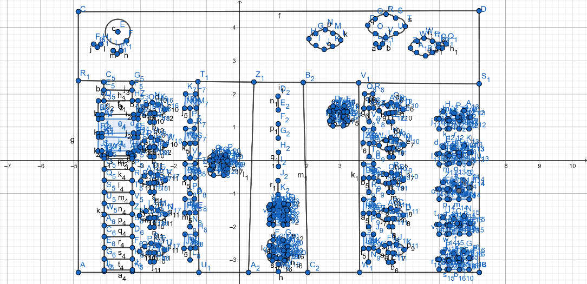
Figure 1: Project Graph plot

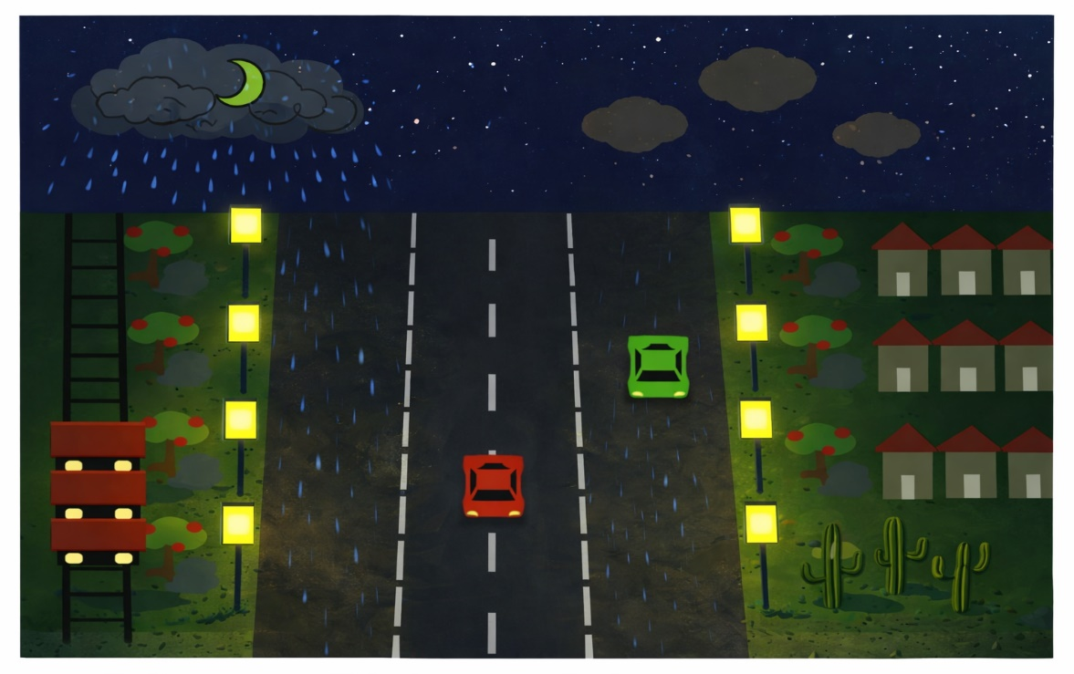

Figure 2: Racing game design

In the design phase of the game, we focused on creating a multi-lane racing environment with the following elements:
- Road Area: A straight 2D road with lane markings, pedestrian walkways, and roadside lamps.
- Player Car: Controlled using the keyboard's arrow keys for lane switching and speed adjustments.
- Opponent Cars: Moving towards the player with randomized lane selection and gradually increasing speed.
- Environmental Scenarios: Day, night, winter, and snow for varied gameplay, with stars visible in the night mode to enhance visual appeal.

3. Game Levels
The game is divided into five levels, each offering unique environmental and gameplay challenges:
- Level 1: Beginner (Rainy) – This level introduces basic gameplay with rainy weather, affecting visibility and road conditions.
- Level 2: City Rush Hour – The player faces faster-moving opponent cars in a city environment with dense traffic.
- Level 3: Foggy Mountain – Visibility is drastically reduced due to fog, requiring careful navigation and slower speeds.
- Level 4: Snowy Peaks – Slippery roads due to snow make it challenging for the player to maintain control of their car.
- Level 5: Desert Highway – Features a road with dust storms that add difficulty.

4. List of Objects Assigning an Object ID
The objects in the game are assigned unique Object IDs for efficient identification and manipulation. These include:
- ROAD: The track where the player and AI cars race.
- PLAYER_CAR: The player-controlled car.
- OPPONENT_CAR: The AI-controlled opponent cars.
- TREE: Trees placed along the road as scenery.
- LAMP: Street lamps that light up the road at night.
- HOUSE: Buildings that appear along the side of the road.
- SKY: The sky that changes with the time of day.
- RAIN: Raindrops that simulate rainy weather.
- BIRD: Birds that fly across the screen during certain levels.

5. List of Functions to Represent Objects
The game uses several functions to draw and manipulate the objects in the game world. These functions include:
- drawRoad(): Renders the road where the car moves.
- drawPlayerCar(): Renders the player's car based on current position and speed.
- drawOpponentCar(): Renders the AI-controlled opponent cars.
- drawTree(): Draws trees along the sides of the road.
- drawLamp(): Renders street lamps at night.
- drawHouse(): Renders houses along the roadside.
- drawSky(): Draws the sky, changing colors based on day and night.
- drawRain(): Renders raindrops falling during rainy weather.
- drawBird(): Renders birds flying across the sky.

6. List of Animation Functions with ID
To bring the game to life, several animation functions are used to update the game world and render dynamic elements. These include:
- movePlayerCar(): Animates the movement of the player's car in response to user input.
- moveOpponentCars(): Animates the movement of opponent cars, making them appear to race against the player.
- moveRain(): Animates the rain, making it fall continuously from the top of the screen.
- moveBirds(): Animates birds flying across the sky in different directions.
- changeDayNight(): Animates the transition between day and night.
- changeWeather(): Updates the weather conditions based on user input or level changes.

7. Contribution
- 1.1 Sadia Mahan Auti
- Implemented Functions:
  - drawRoad: Responsible for rendering the road where the player and opponents drive.
  - drawPlayerCar: Implements the function to render the player's car, updating its position based on input.
  - drawOpponentCar: Draws opponent cars on the road, with movement based on AI-controlled behavior.
  - drawTree: Renders trees along the road to create a natural environment.
  - drawLamp: Draws street lamps that illuminate the road at night, adding to the atmosphere.
  - drawHouse: Implements the function to render houses along the road.
  - drawSky: Renders the sky, changing with the time of day and weather conditions.
  - drawRain: Renders the raindrops falling during rainy weather.
  - drawTrain: Implements the function to render a train passing along the road.
- Implemented Animation Functions:
  - movePlayerCar: Handles the movement of the player's car, based on user input.
  - moveOpponentCars: Animates the movement of the opponent cars, making them appear to race against the player.
  - moveRain: Animates the falling rain, simulating real-time weather changes.
  - moveBirds: Moves the birds across the screen, adding to the dynamic environment.
  - changeDayNight: Controls the transition between day and night modes in the game.
  - changeSeason: Changes the season, adjusting environmental elements like snow and rain based on the season.
  - animateWeatherEffects: Adds animation effects for weather conditions such as snow, fog, and rain.
  - animateTraffic: Implements the animation for the traffic movement, making the roads feel busy and dynamic.
  - animateWeather: Creates smooth transitions for weather effects like snow, rain, and fog.
  - animateObjectsInScene: Ensures that trees, buildings, and other objects in the environment move and interact in a natural way.
- 1.2 Mohtasin Shahriar Tanbin
- Implemented Functions:
  - drawTree: Responsible for rendering trees with different styles based on the game’s environment and level.
  - drawLamp: Implements the function to render the street lamps, adjusting their appearance based on day and night modes.
  - drawHouse: Renders houses along the sides of the road, creating a more immersive environment.
- Implemented Animation Functions:
  - animateTreesAndHouses: Animates the trees and houses, creating subtle movements such as branches swaying in the wind.
  - animateTraffic: Controls the movements of cars and objects that simulate a busy road environment.
- 1.3 Saiful Islam Shimul
- Implemented Functions:
  - drawRain: Renders raindrops, ensuring they fall in a manner that simulates real-world rain.
  - drawSky: Renders the sky with appropriate lighting for different weather conditions and times of day.
- Implemented Animation Functions:
  - animateRain: Controls the movement of the rain, creating an effect where rain continuously falls from the sky.
  - animateFog: Animates the fog effect during certain levels, simulating real-world fog by altering visibility.

8. Output

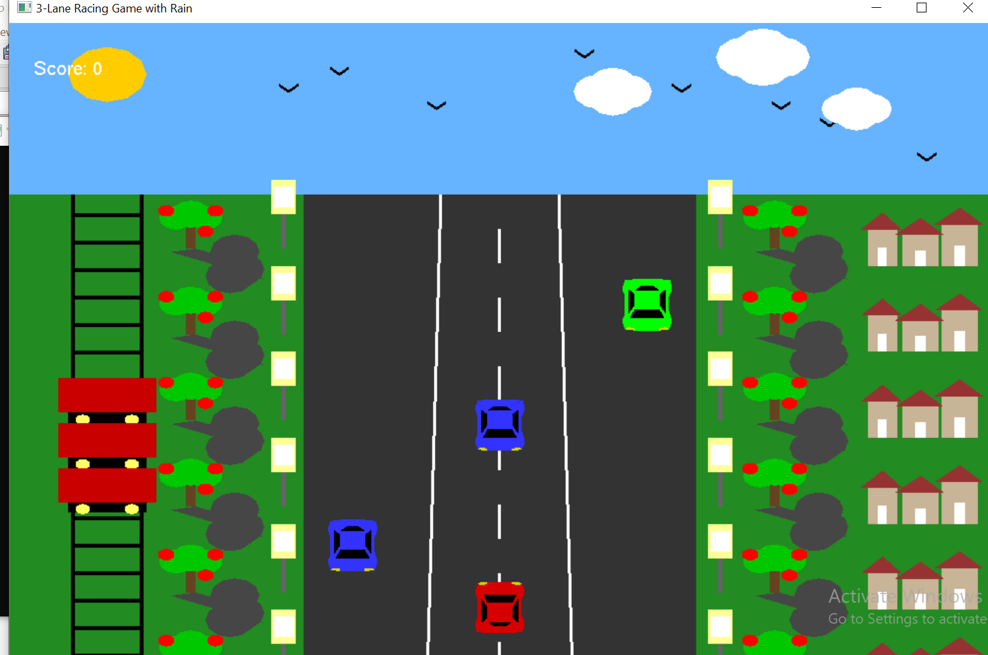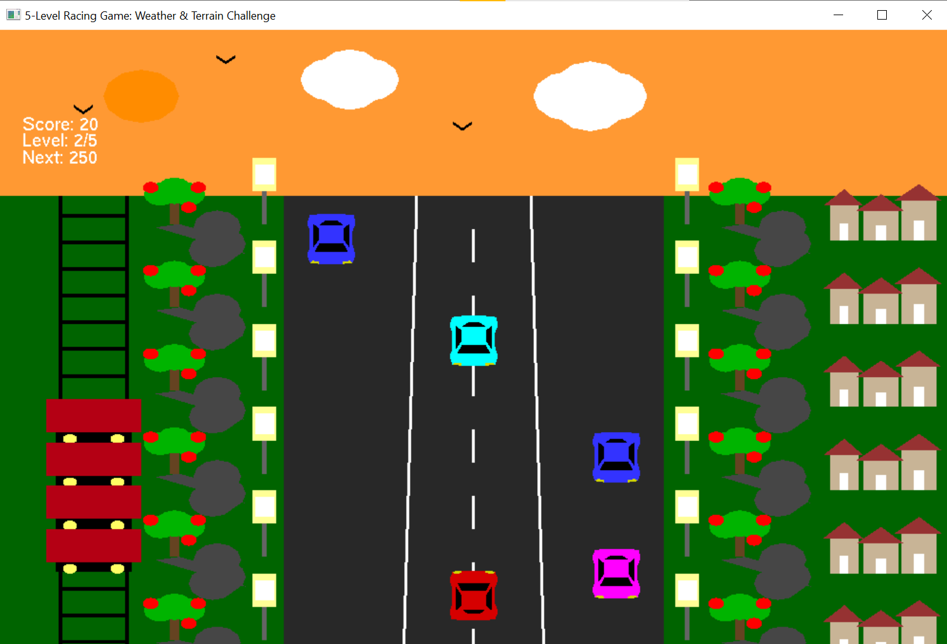
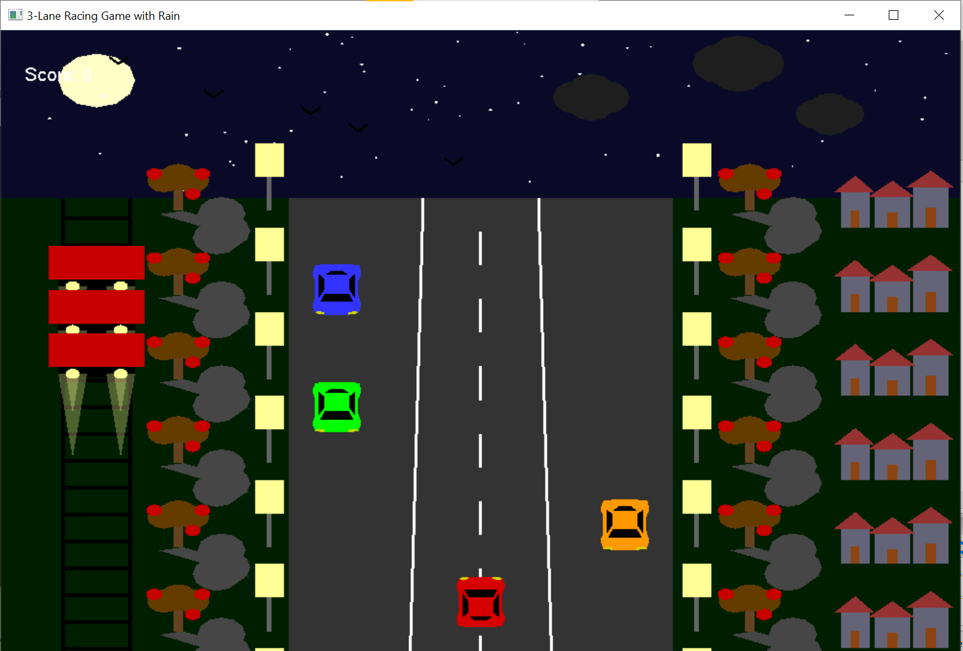
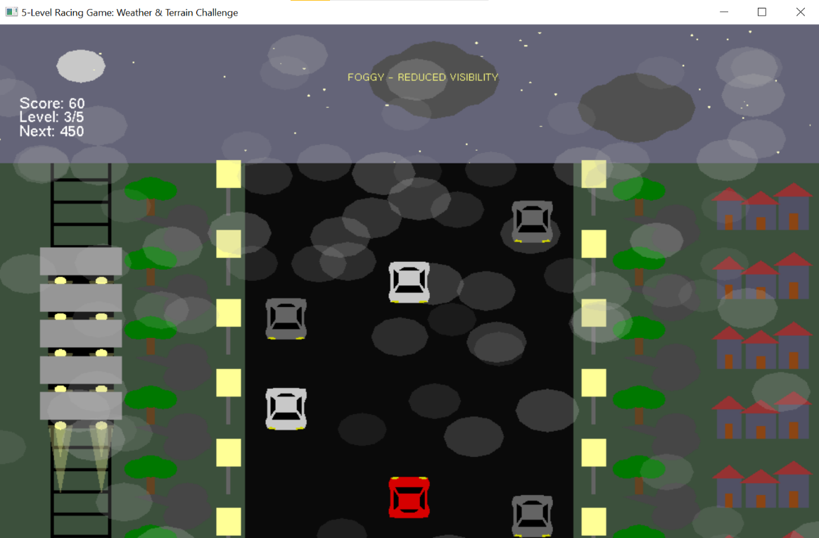
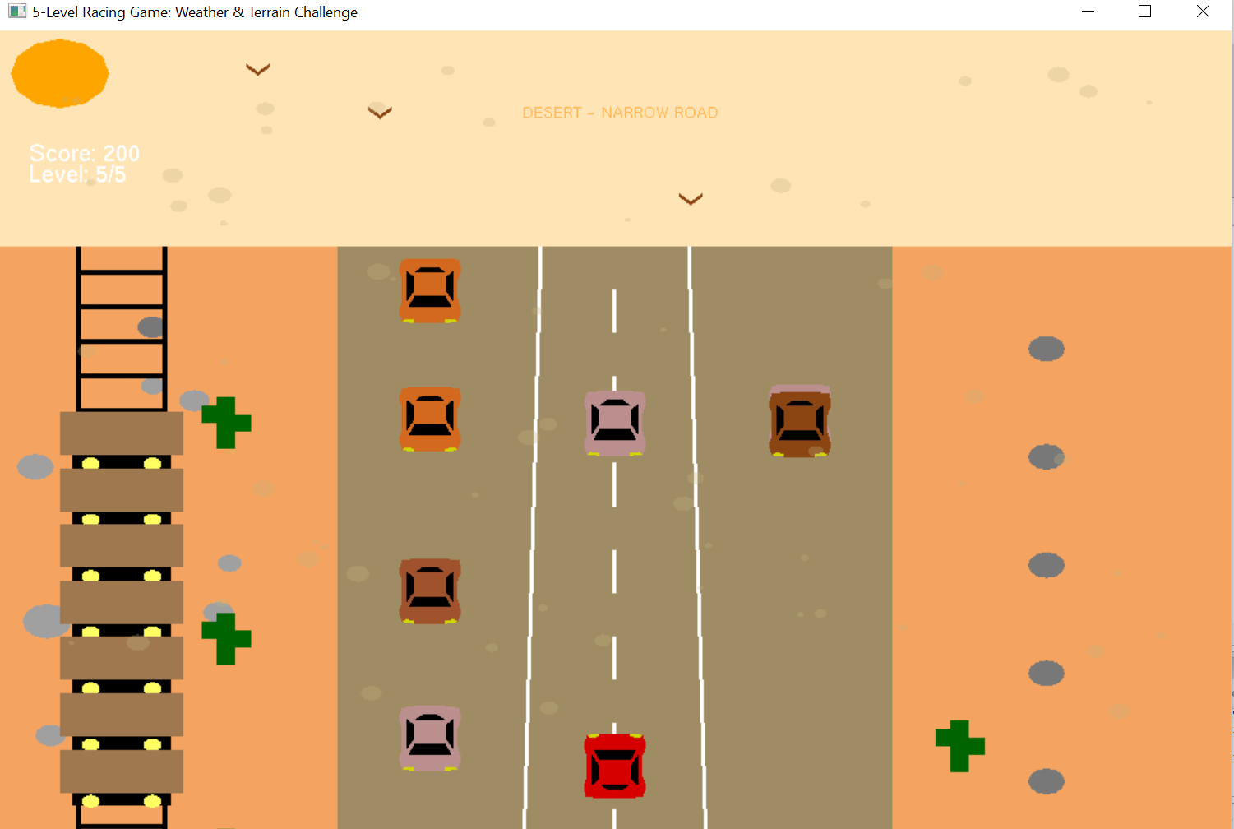

9. Controls
The game is controlled using keyboard and mouse inputs:
- Mouse Controls:
- Left-click: Pause or resume the game.
- Right-click: Pause or resume the night train.
- Keyboard Controls:
- D / N: Toggle between Day/Night mode.
- Arrow Up/Down: Control the speed of the car.
- Arrow Left/Right: Change the car’s direction (left or right).
- W / S: Move the car up or down the track.
- A / D: Switch lanes.
- H: Toggle heavy rain conditions.

10. Description of Project
This section describes the overall design and the purpose of the project. The game is designed to be a fun, interactive racing simulation with dynamic weather and environmental effects. It challenges the player to navigate through various levels, each with its own set of obstacles and challenges. By using OpenGL and C++, the project incorporates graphical rendering techniques, real-time animations, and object manipulation.
11. Functionalities
The game offers a range of functionalities, such as:
- Lane switching: Players can change lanes to avoid obstacles and opponent cars.
- Real-time weather effects: Weather conditions like rain, snow, and fog dynamically change the environment, affecting gameplay.
- Opponent AI: The game features AI-controlled cars that follow pre-defined paths and attempt to race against the player.
- Collision detection: The game detects collisions between the player’s car and opponent cars, leading to a game-over scenario if a collision occurs.
12. Important OpenGL Functions
The game uses several OpenGL functions for rendering graphics, managing transformations, handling input, and implementing environmental effects:
- Rendering Objects:
  - glBegin(GL_QUADS) / glEnd(): Draws rectangular objects like roads, buildings, and cars.
  - glBegin(GL_TRIANGLES) / glEnd(): Used to render triangles, such as trees, clouds, and other environment elements.
  - glVertex2f(): Defines the vertices of shapes for rendering.
- Transformations:
  - glTranslatef(): Translates (moves) objects in the 3D space (used for moving cars, trees, etc.).
  - glRotatef(): Rotates objects around an axis (used for rotating birds, for example).
  - glScalef(): Scales objects by a given factor (used for resizing objects like the player’s car).
- Color and Lighting:
  - glColor3ub(): Sets the color for drawing objects.
  - glEnable(GL_BLEND): Enables transparency effects, useful for weather effects like snow and rain.
  - glBlendFunc(GL_SRC_ALPHA, GL_ONE_MINUS_SRC_ALPHA): Defines how blending should happen for transparent objects.
- Animation:
  - glPushMatrix() / glPopMatrix(): Saves and restores the current transformation matrix. This allows individual objects to move or rotate without affecting others.
  - glutTimerFunc(): Sets up a timer to periodically call a function, typically used for updating object positions (e.g., for car movement, weather effects).
- Text Rendering:
  - glRasterPos2f(): Sets the position where text will be rendered on the screen.
  - glutBitmapCharacter(): Renders individual characters at the specified position. Used for displaying scores, level names, and instructions.
13. Conclusion
The "Racer X-City Drift" project effectively demonstrates the integration of OpenGL and C++ to create an interactive racing game. By utilizing various graphical techniques, weather effects, and real-time transformations, the game offers an engaging experience that challenges the player’s driving and navigation skills. The modular design of the game ensures that future enhancements can be easily implemented, such as adding new levels, additional weather effects, and more complex AI behavior.
This project reinforces key concepts in computer graphics, such as object manipulation, collision detection, state-driven rendering, and environmental simulation. It serves as an excellent example of how OpenGL and C++ can be leveraged to create a visually compelling and interactive game.

